
M.S. 217 School Visit
November 19, 2025, 10:00 am
Olessia Bauer, CEC28 School Liaison Report

The tour of the school was conducted by Principal Angela Teutschman. The notes were taken by Olessia Bauer, CEC28 Treasurer.
The following observations were made during the tour:
- The school hosts 6th grade students in a trailer which is detached from the main building. The trailer shows signs of water damage in hallways, classrooms, bathrooms, interior and exterior walls.

The boy’s bathroom is permanently closed due to standing water on the bathroom’s floor. The old rusted pipes can no longer be fixed by the school’s maintenance to prevent water leakage. The walls and pipes are crumbling in the bathroom and throughout the building.

The 6th graders take an outside path to access bathrooms, cafeteria, gym, and auditorium in the main building.

The trailer was built as a temporary addition to the school. Its longevity was estimated to be 7 years. The trailer is 25 years old. It is not compliant with the building codes.

Next to the trailer is a small yard acting as a soccer field. This yard’s surface is uneven and partly covered by standing water.

- A city park is adjacent to the school. The students use the park before and after school to play soccer or basketball. The park’s surfaces have countless number of potholes. Missing parts of the soft covering under the playground are trip hazards and have caused multiple injuries.

The park’s equipment is old and lacks functionality. The park is not maintained by the city, the trash is not picked up, the leaves are not removed, the trees are not trimmed, and the broken equipment is not replaced.

Every morning at 7:00 am on school days, two school’s security officers check the playground and remove homeless individual from the park to ensure safety of the students.

Consumption of recreational drugs and alcohol by the general public is a regular occurrence in the park.

- Inside the main building, two constructions projects are not finished.

In summer 2025, blue prints were prepared by SCA and signed by Principal Teutschman in order to start building a STEM lab and an exercise room. The school agreed to prepare two rooms for the construction. The school spent $100,000 to remove the old lockers, check walls for asbestos, prepare walls, floors, ceilings, plumbing, and electrical for the new construction to begin. In September of 2025, the SCA notified Principal Teutschman that they will not hold their end of the agreement. The project will not move forward. The principal’s requests for explanation have not been answered.

- The cafeteria is not well-lit. The dark green floors, low hanging grey ceiling along with the poor illumination make the cafeteria unwelcoming. Tables on wheels are used in the kitchen and the dining area. These tables were introduced as temporary measures to improve functionality and sitting space. They lost their appeal and functionality over years. The original floors show signs of wear.

- The gym is a good size. The walls are not padded. The bleachers and the floors show signs of wear.

- The roof of the main building has been upgraded. However, the solar panels were not installed after the upgrade as originally planned.

In conclusion, the main building is in need of remodeling to provide the students and staff with a safe and functional school. The trailer building and the yard are in extremely poor condition. The trailer should be replaced with a new building and be attached to the main building of the school. The STEM lab and the exercise room should be finished according to the prior agreement with SCA.
Attachments:
- STEM lab is not finished. A room was cleaned by the school, but it has not been converted to a STEM lab. The school is waiting for the SCA to explain why the project was stopped.
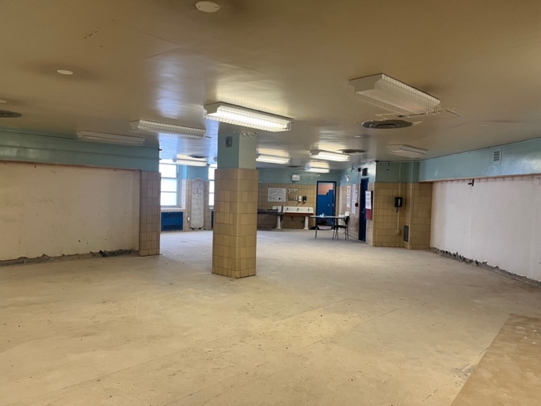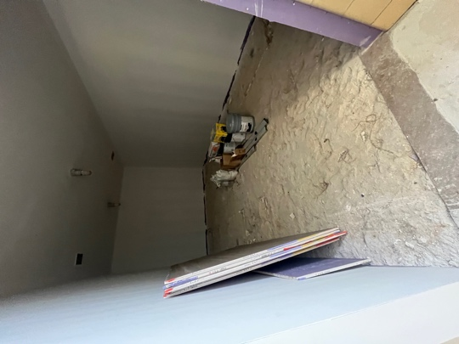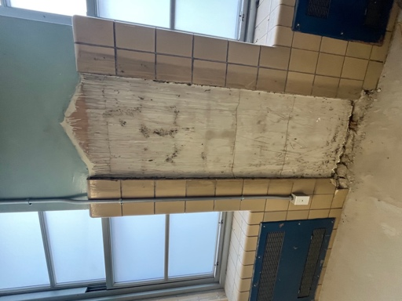

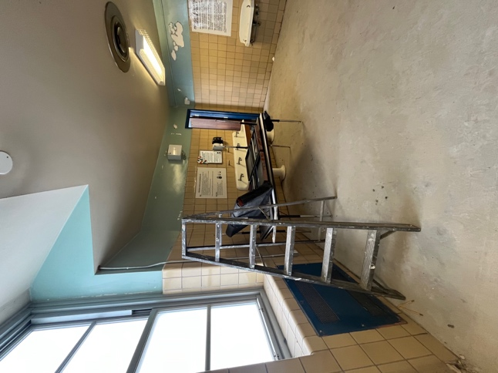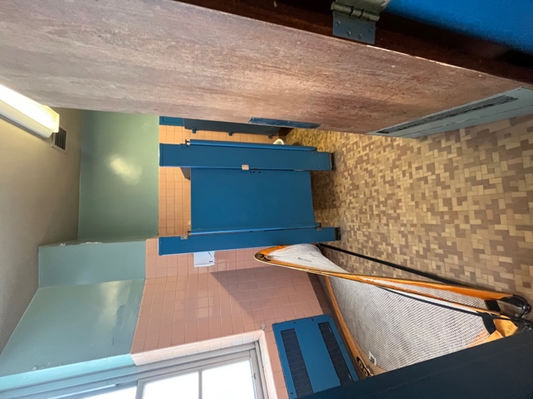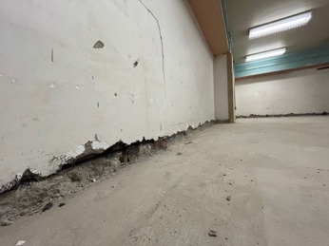

- Cafeteria. Food is served from temporarly carts on wheels. A permonent serving counter will provide a better view of the food and quicker service. 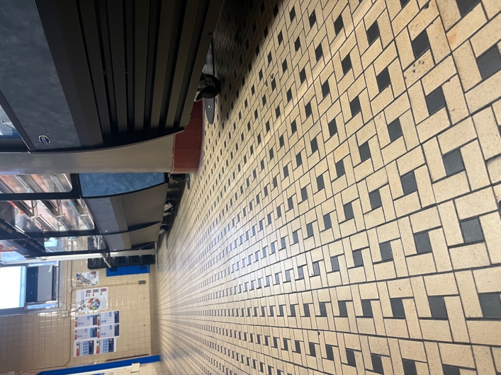 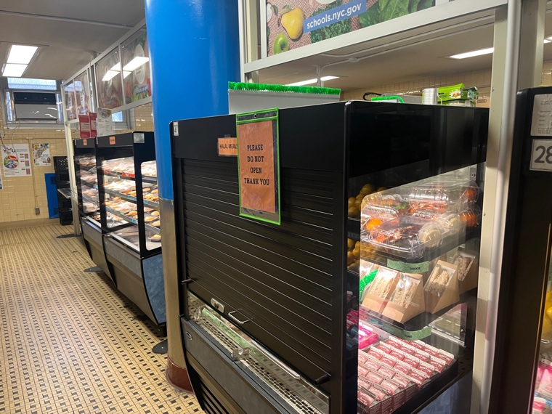
- City Park attracts homeless. The playground equipment is unsafe for the students and the community. Many injuries were reported in the past.

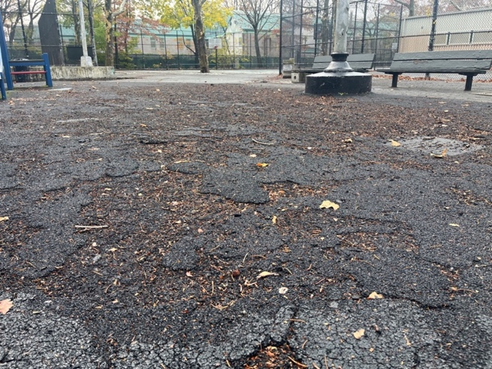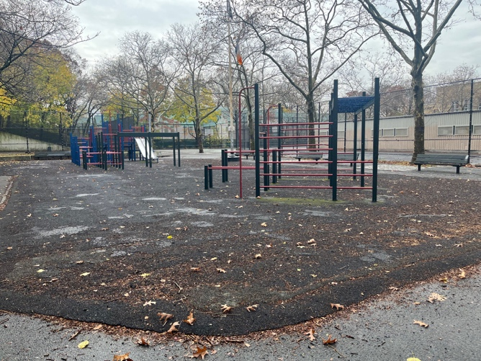
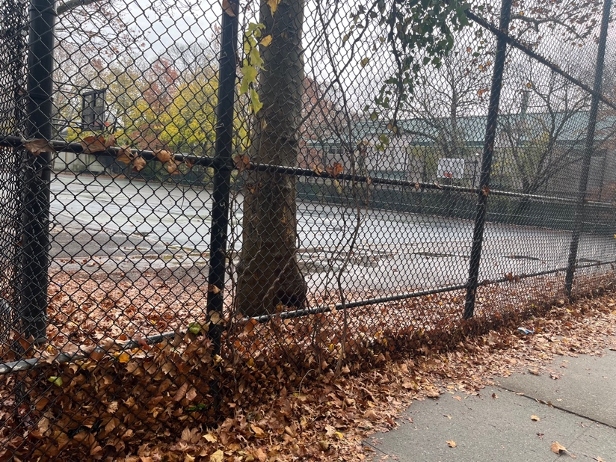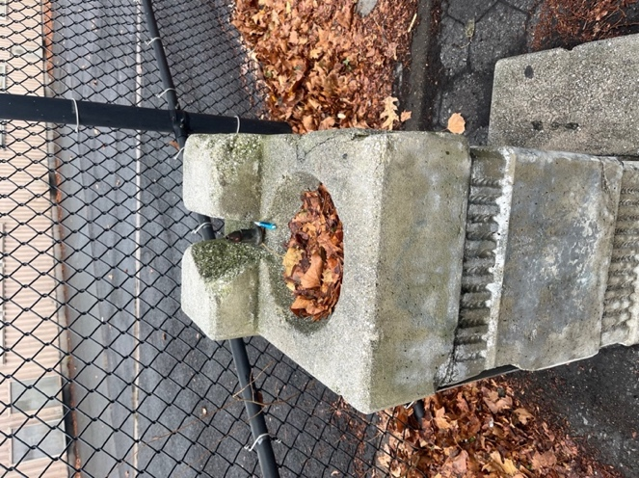
The school maintains part of the yard, with not enough financing the yard is almost abandoned. 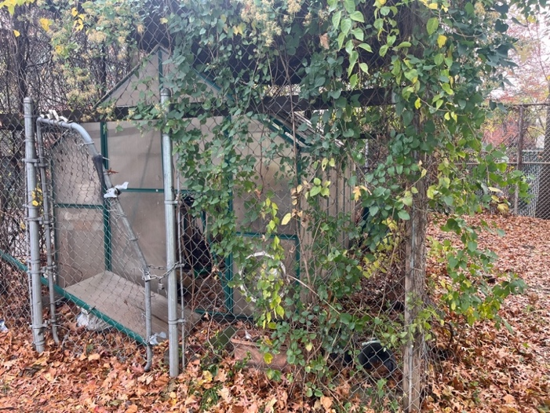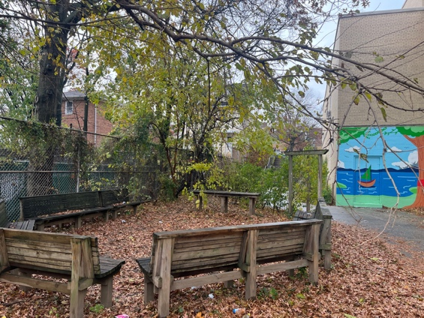
- The trailer building is in critical condition. Standing water and water damage to the interior and exterior walls are shown on the pictures below.

Interior of the trailer:
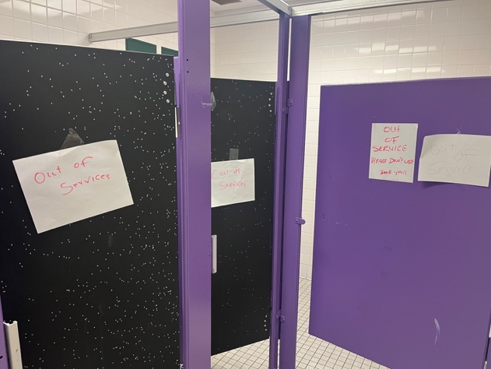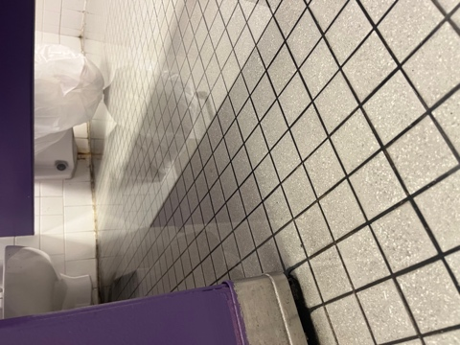
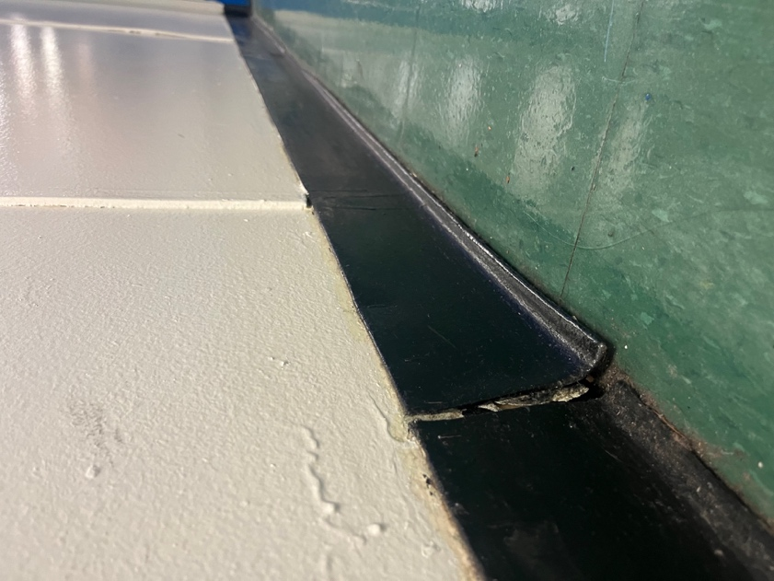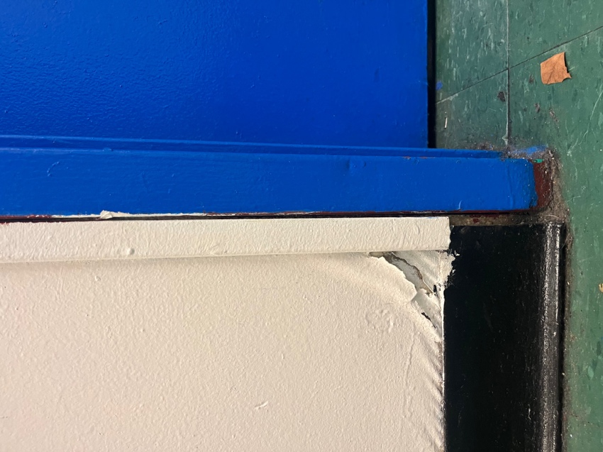
Exterior of the trailer:
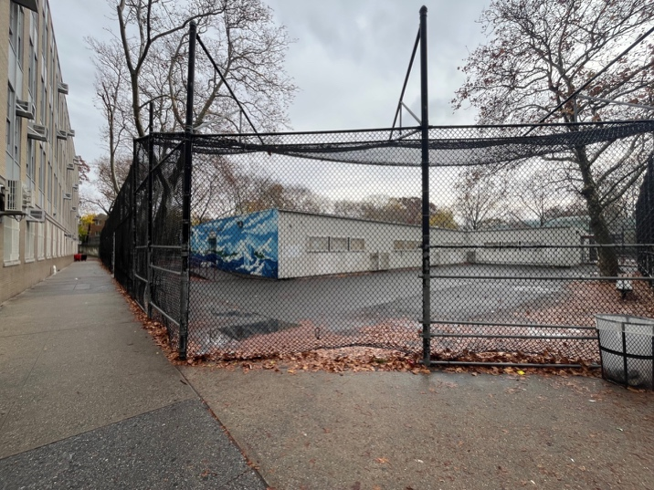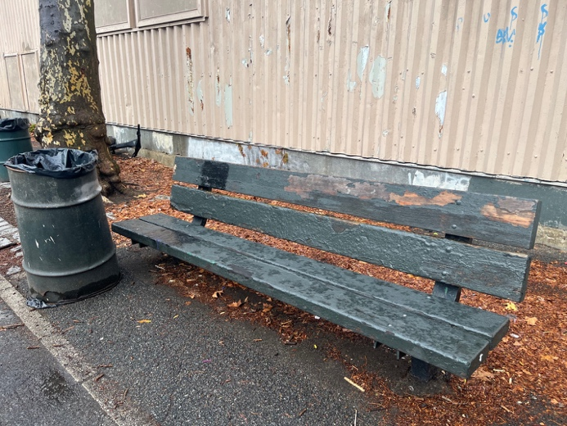

Soccer field adjacent to the trailer:
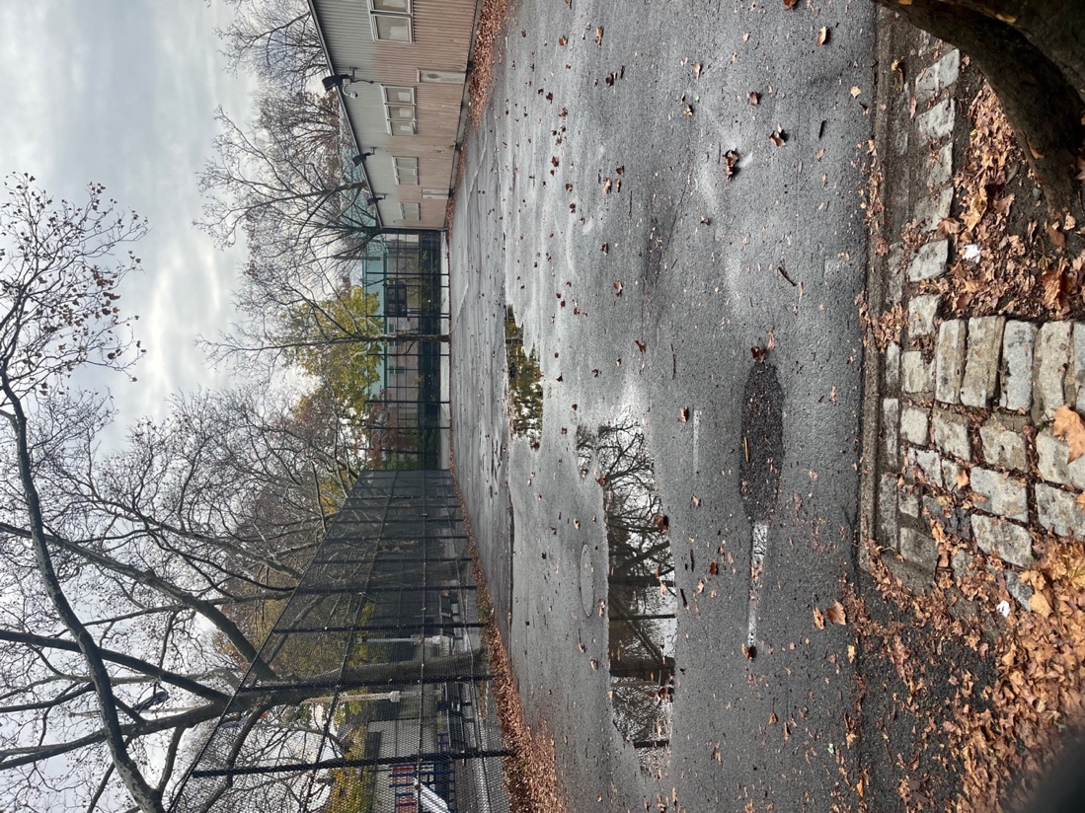
Basketball field of city parks adjacent to the trailer:
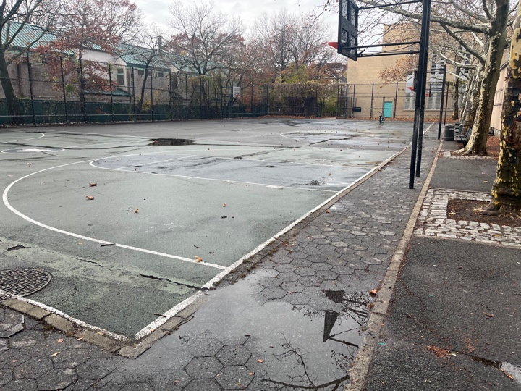

The walkway to the main building from the trailer.
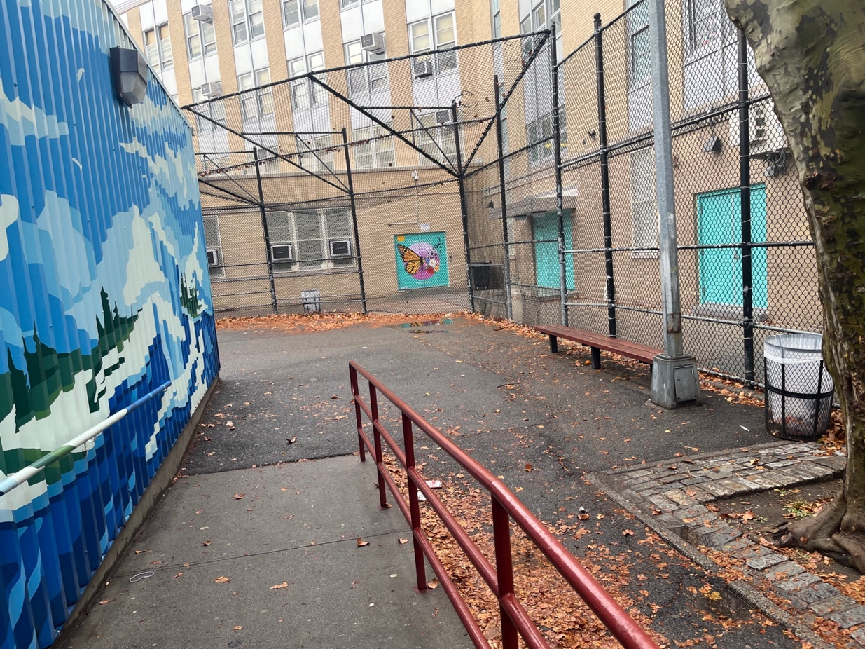
- Gym.
